KheloIndia

Submitted in partial fulfillment of the requirements of the degree

## BACHELOR OF ENGINEERING IN INFORMATION TECHNOLOGY

By

### Preet Bhansali Roll No 10

### Amar Sahu Roll No 98

### Jay Seth Roll no 103

Supervisor

## Prof. SANOBER SHAIKH



Department of Information Technology

Thadomal Shahani Engineering College,

Adv. Nari Gurshahani Marg, TPS III ,Off Linking Rd,

Bandra West, Mumbai, Maharashtra 400050

(Academic Year 2020-21)

# CERTIFICATE

This is to certify that the Mini Project entitled “KheloIndia ” is a bonafide work of PREET BHANSALI(10), AMAR SAHU (98)

and JAY SETH(103) submitted to the University of Mumbai in partial fulfillment of the requirement for the award of the degree of “Bachelor of Engineering” in “Information Technology” .

**Prof. SANOBER SHAIKH**

Supervisor

#### Dr. Arun Kulkarni Dr. G.T. Thampi

Head of Department Principal

# Mini Project Approval

This Mini Project entitled “KheloIndia” by GROUP of PREET BHANSALI Roll No 10, AMAR SAHU Roll No 98 and JAY SETH Roll no 103 is approved for the degree of Bachelor of Engineering in Information Technology.

**Examiners**

**1………………………………………**

(Internal Examiner Name & Sign)

#### 2…………………………………………

(External Examiner name & Sign)

Date: Place:

# Contents

|  |  |  |
| --- | --- | --- |
| **Abstract** |  | **i** |
| **Acknowledgment** |  | **ii** |
| **List of Figures** |  | **iii** |
| 1. **Introduction**    1. **1.1** Introduction | 1 | **1** |
| **1.2** Motivation | 3 |  |
| **1.3** Problem Statement & Objectives | 4 |  |
| **1.4** Organization of the Report | 5 |  |
| **2 Literature Survey** |  | **6** |
| **2.1** Survey of Existing System | 6 |  |
| **2.2** Limitation Existing system or research gap | 7 |  |
| **2.3** Mini Project Contribution | 7 |  |
| **3 Proposed System** |  | **8** |
| **3.1** Introduction | 8 |  |
| **3.2** Architecture/ Framework | 9 |  |
| **3.3** Algorithm and Process Design | 14 |  |
| **3.4** Details of Hardware & Software | 13 |  |
| **3.5** Experiment and Results | 22 |  |
| **3.6** Conclusion and Future work. | 23 |  |
| **References** |  | **24** |

## Abstract:

We at KheloIndia, have come up with this project KheloIndia, which will act like a bridge to fill these information gaps and other problems.

We believe that every individual has the power to bring happiness. So when you have the power to do such great things then why cannot we do something to bring smiles in face of needy people.

We believe that every donation matters whether it is small or big but the willingness to donate and help someone also plays a big role in helping the needy people.

Major goals of this project are:

* To provide Social, Educational and Economic Empowerment to athletes .
* To help to act as a bridge between non-profit organisation and the needy people so that their needs are fulfilled.
* To identify the homeless and the destitute and facilitate their relocation in appropriate institutions who are aiming to excel in ground of sports.
* To provide medical, financial and legal aid and assistance to the athletes and to take such other measures to ensure their social well-being.
* To take such other measures and render services or assistance including establishment of information centres, provision for grounds, clubs, setting up of educational, research and training institutions, etc., to the aforesaid class of persons and other persons, as may be necessary from time to time for the betterment of society.
* To empower the needy athletes by providing, medical aid and other appliances.
* To associate ourselves with any other institution, Society or Association, having objectives wholly or in part, similar to those of ours and to co-operate with any person or body of persons in furtherance of such objectives.
* Donating goods to the needy athletes and provide them goods which will help them to excel in there desired sport.

**ACKNOWLEDGEMENT**

We express our deep gratitude and regards to Prof. Sanober Shaikh, Internal Guide and Assistant Professor for her encouragement and valuable guidance in bringing shape to this dissertation. We are thankful to all the Professors and Faculty Members in the department for their teachings and academic support and thanks to Technical Staff and Non-teaching staff in the department for their support.

#### PREET BHANSALI 10

**AMAR SAHU 98**

**JAY SETH 103**

**List of Figures**

|  |  |  |
| --- | --- | --- |
| **Fig.no** | **Name** | **Page no** |
| 3.4.1 | Home Page | 14 |
| 3.4.2 | About Us | 15 |
| 3.4.3 | Welcome Page | 15 |
| 3.4.4 | User Login | 16 |
| 3.4.5 | User Registration | 16 |
| 3.4.6 | Forget Password | 17 |
| 3.4.7 | Donate Page | 17 |
| 3.4.8 | Donate Money | 18 |
| 3.4.9 | Donate Goods | 18 |
| 3.4.10 | Sports Page | 19 |
| 3.4.11 | Hockey Page | 19 |
| 3.4.12 | Shooting Page | 20 |
| 3.4.13 | Badminton Page | 20 |
| 3.4.14 | Table Tennis Page | 21 |
| 3.4.15 | Achievements Page | 21 |
| 3.4.16 | Maps Page | 22 |
| 3.4.17 | Ground & Clubs Page | 23 |

## Chapter 1: Introduction

### Introduction:

* The importance of sports and fitness in one’s life is invaluable. Playing sports inculcates team spirit, develops strategic & analytical thinking, leadership skills, goal setting and risk taking. A fit and healthy individual leads to an equally healthy society and strong nation.
* Sports is an extremely important component for the overall development of our nation. India, in the last few years has made steady progress in the field of sports.
* This tremendous potential needs to be showcased at a global platform. It’s time we inspire young talent, give them top-notch infrastructure and training of the highest level.
* We need to inculcate a strong spirit of participation in sports that enables players to demonstrate their true potential. Only then can India realise its dream of becoming a sports super power.

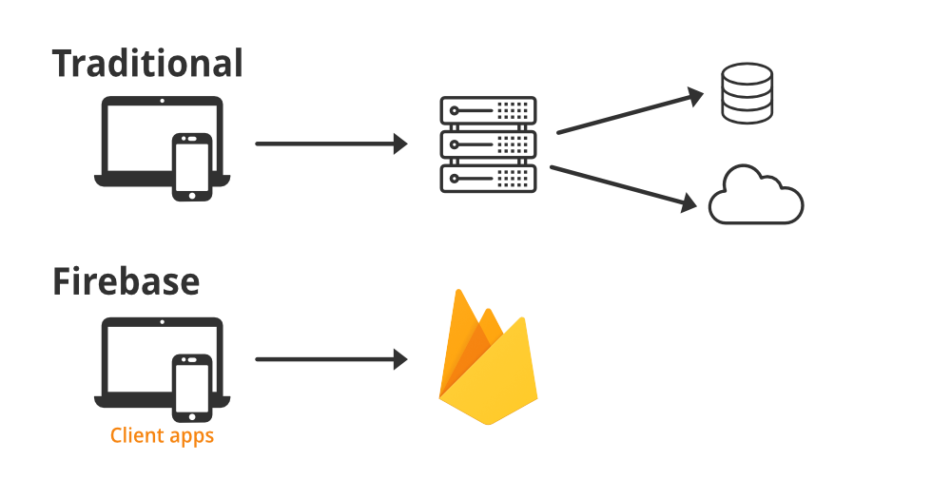

**1)FIREBASE**

The Firebase Realtime Database is a cloud-hosted database. Data is stored as JSON and synchronized in realtime to every connected client. When you build cross-platform apps with our iOS, Android, and JavaScript SDKs, all of your clients share one Realtime Database instance and automatically receive updates with the newest data.

Firebase is a platform developed by Google for creating [mobile](https://en.wikipedia.org/wiki/Mobile_phone_application) and [web](https://en.wikipedia.org/wiki/Web_application) applications. It was originally an independent company founded in 2011. In 2014, Google acquired the platform[[1]](https://en.wikipedia.org/wiki/Firebase#cite_note-1) and it is now their flagship offering for app development.

Firebase evolved from Envolve, a prior startup founded by James Tamplin and Andrew Lee in 2011. Envolve provided developers an API that enables the integration of online chat functionality into their websites. After releasing the chat service, Tamplin and Lee found that it was being used to pass application data that were not chat messages. Developers were using Envolve to sync application data such as game state in real time across their users. Tamplin and Lee decided to separate the chat system and the real-time architecture that powered it.[[2]](https://en.wikipedia.org/wiki/Firebase#cite_note-2) They founded Firebase as a separate company in 2011 and it launched to the public in April 2012.

Firebase has been claimed to be used by Google to track users without their knowledge. On July 14, 2020, a lawsuit was filed accusing Google of violating federal wire tap law and California privacy law. It stated that through Firebase, Google collected and stored user data, logging what the user was looking at in many types of apps, despite the user following Google's own instructions to turn off the web and app activity collected by the company.

**2)HTMLWITH FIREBASE:**

Following are some simple steps in order to connect our static Web Page with **Firebase.**

**Step 1:** Firstly, We are going to createa project on Firebase to connect our static web page. Visit the [Firebase](https://console.firebase.google.com/u/0/) page for **configuring**your project. Visit the website and click the On **Add Project** button as shown below.

The constant emerging technologies in the world of web development always keeps the excitement for this subject through the roof.

**Step 2:**Give a **Name**to your project and click on the **Continue**button.

**Step 3:**Now click on the **Continue**button.

**Step 4:** Now choose **Default Account For Firebase** and click on the **Create Project**button.

**Step 5:**Give a **nickname**to your web project and click on the **Register App**button.

Now Createan **HTML** file and copy the **script**code which you copied in **Step 8**. The following file is just a sample for you to understand how to **configure**your project.

### Motivation:

The purpose behind making KheloIndia website was looking at 2020 Tokyo Olympics. People in India have passion related to a particular sport but they don't know where to start and from whom to take proper guidance which leads to criticism that India does not achieve much medals.

This portal will help people know the sport in depth with perfection and scope for them to compete at different levels.

Also this portal will have an impact on the needy people who are talented but don't have enough money for the best training. So overall the pandemic and Olympics drove us to plan KheloIndia for a sporty India.

The main motive of KheloIndia are as follows:

**1. Motivation through Fear**

First, instilling fear in others is simple (and it can quickly motivate some people) but over time, fear can easily breed resentment and disloyalty. The athlete who is motivated by fear is likely not so much trying to achieve something as they are trying to avoid something (e.g., losing a position or making a mistake). This athlete generally becomes focused on what not to do, rather than what to do. In time, this can become stressful and lead to a strong sense of resentment and/or disloyalty toward the one instilling the fear.

**2. Motivation through Incentives**

Incentives too can be effective for the short-term. Dangling the "carrot" (e.g., playing time, money, trophies, etc.) is a strong motivator for many athletes but these extrinsic means generally last for only a short time before the "incentives" need increased or made more appealing. The less appealing the incentive, the less motivation one will generally show.

**3. Motivation through Purpose**

Finally, developing a strong sense of purpose is most effective for promoting long-term motivation. Creating a sense of purpose and/or meaning is about changing the way athletes think about their roles, their reasons for coming to practice, their influence on teammates, their membership on the team, and their reasons for playing and competing. Providing purpose and meaning is about creating an environment that is conducive to personal growth and encouraging athletes to motivate themselves, as well as inspire their teammates. Developing purpose and meaning takes more time and energy (investment) but it can lead to that long-term motivation for which most coaches are striving.

### Problem Statement & Objectives:

**Problem Statement:**

As we all know that Olympic is at the best and a very hot topic at present almost at everyone’s place. During the Olympics the young generation gets the craze of joining sports which interest them the most and often end up joining the coaching centers which teach them the techniques but there’s no scope of playing the game at levels.

This eventually leads to lack of knowledge about the sport leading to loss of interest in sport with passing time. We have come up with the website which is called KheloIndia.

It is a platform where anyone and everyone will be able to know what the sport is about, what levels we need to pass through to reach at the top. The website will help youth to pursue to best training for them and which will help people to be aware about the different types of sports played all across the world and also we blame the present situation of not winning medals at the Olympics as we never promoted or were devoted to sports.

The website includes the admin and the registration/login side wherein the admin will handle all the donations and the money flow for coaching of needy people. The login side consist of all the achievements that our honored athletes have won and got pride to our country. It will also include about the achievements of the best across the world. Then it includes about the various competitions or levels at which a person plays at which defines the efficiency of that athlete to compete at different levels.

We all know finding grounds is not an easy job it metropolitan cities so we will be providing information about the grounds nearest to them. Then we have the facility for people to look for the best clubs and organizations which will provide them the best training and give a hope to play at levels and secure a good name for them. Also as we know a coach plays a vital role in shaping ones future, so we will be providing the list of best coaches who have made people an icon for the youth and have been an inspiration. We will be providing all of the information about 10 sports which will have 10 options for each sport.

An all in one website for one and all. Also we will be providing an option of donating goods or money which will be used for the ones who can’t afford the coaching or the equipment’s required for that particular sport which will help India get talent and no one will have to kill their dreams because of their poor financial conditions.

### 

### Objectives:

Through this project KheloIndia, we want to achieve the following objectives:

* To provide Social, Deep Educational knowledge about sports.
* To help to act as a bridge between non-profit organization and the needy people so that their dream to play any sport of their choice is fulfilled.
* To donate sports goods for the under privileged people who cannot play sports due to lack of equipment or financial conditions.
* To provide information about the sports and also along with that to make them aware about the achievements made by our Indian players in various sports at national level as well as internationally.
* To make people aware about the best coaches across India so that nothing can stop them to achieve milestones in their life and keep no stones unturned.
* To make them aware about the sports clubs/organizations around them to get into them and play at various levels and get a place towards a secured future.
* To empower the needy people by providing them help financially and sports wise.

### 

### Organization of the Report:

**Chapter 1:** Consist of Introduction to Firebase and motivation about why we use Firebase, what is its importance in today’s world. It also includes the problem statement of our project KheloIndia.

**Chapter 2**: Consist of the Survey of the already existing system in the market and what are the limitations in the existing system and the resource gaps. It also includes what benefit our society will get by using the application KheloIndia

**Chapter 3**: Includes information about the proposed system, the architecture and framework used in the project, design of the frames, details of hardware and software used and the snapshots of the results from the project. Also includes Conclusion and future work.

## Chapter 2: Literature Survey

### Survey of Existing System:

Sports based App. ‘KheloIndia’ is a programme that has been introduced to revive the sports culture in India at the grass-root level by building a strong framework for all sports played in our country and establish India as a great sporting nation.

To accomplish the above objectives, KheloIndia programme has been divided into 6 verticals, namely:

* Play field development: In this the people will be able to have knowledge about how do things work on the field and outside the field. How strategies related to a particular sport is to be made while in the game and before starting the game.
* Community coaching development: In this people will be coached under the best coaches and community as a whole will be improving their skills in a particular sport which will be betterment for achievements for India.
* State level KheloIndia centres: There are various centres located across India so that everyone takes advantage of this programme and the participation increases.
* Annual sports competition: They arrange competitions so that they find winners and improve their game and send them to play at various levels and represent India and bring pride to our nation.
* Talent search and development: It focuses and brings up the pure talent by not being biased towards any person and bring overall development of every person that joins this program.
* Upgradation of sports infrastructure: Being a part of any sport means that it needs to have an updated and well maintained place to play so that it gives good vibes and the performance improves every day and for that upgradation is necessary. They focus towards the upgradation of sports infrastructure.
* Support to national/regional/state sports academics: It plans to help the national regional and the state sports academies for growing the centres well and inculcating efficient techniques in people who coach themselves at these centres.
* Physical fitness of school children: One needs to be fit to play an sport with his full strength and for that fitness camps are organized by KheloIndia which keeps the school children fit and keeps then spirited to play sports.
* Sports for women: KheloIndia not only focus on development of men/boys but also works for the development of girls/women. They organize events for women as well and coach women in their desired sports.
* Promotion of sports among people with disabilities: It is important that no person feels like he is less than the others and KheloIndia keeps that in mind that no person with disability feel bad about not being able to play sport of their desire. They promote sports for the ones with disabilities too so that they feel empowered equally in the society.

### Limitation Existing system or research gap:

### In the existing system, we found that there are some limitations like

### There was no login option which made easy access to the varied features of the website

### The most important thing to keep going ahead is motivation and there is no scope of inspirational quotes to keep the person motivated.

* They don't provide details about all types of sports only well-known sports are highlighted.
* They don't provide option for donation of goods and money to benefit the needy people.
* Lack of information about the clubs and coaches which is not provided.
* Details about the sports played in India are only provided.
* Information related to the achievements made by Indian players at various levels are not mentioned which should have been added in order to encourage upcoming generation to get motivated and increase the success at various levels

### Mini Project Contribution:

* We at KheloIndia, have come up with this project, which will act like a bridge to fill these information gaps and other problems.
* We believe that every individual should be aware about the sports played in india and internationally too. So KheloIndia plans to keep everyone updates about the sports and make them aware about various competitions and also help them reach grounds nearby to them and get trained under the best coaches across India.
* We believe that every donation matters whether it is small or big but the willingness to donate and help someone also plays a big role in helping the needy people.
* So we believe that this project will surely help the donors who are willing to donate as well as the done who is in search of help.

## Chapter 3:Proposed System

### Introduction:

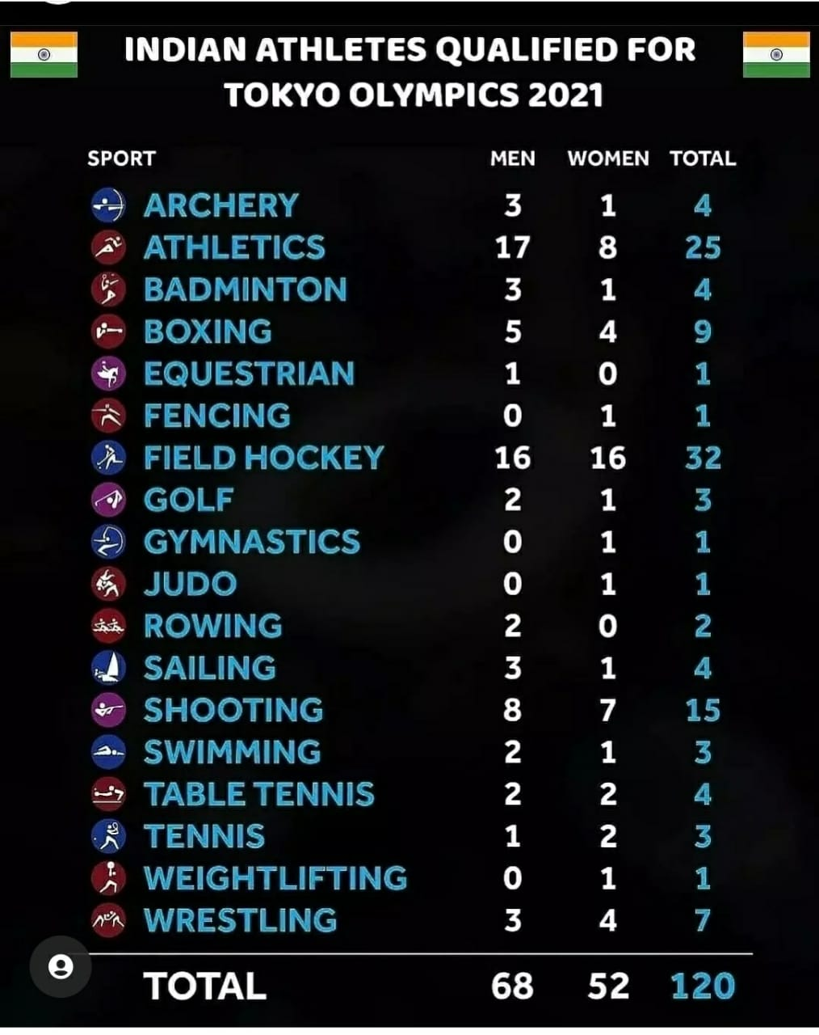

India at Olympics ,Only 120 Participants population of 130 Crores i.e Only 0.001 percentage of population this is because of less knowledge of sports and less importance of many sports in INDIA .

Sports like CRICKET, FOOTBALL, HOCKEY everyone knows that in INDIA but sports like EQUESTRIAN, FENCING, RUBDY,TAEKWONDO, ARTISTIC GYMNASTICS, BASEBALL,CANOE SLALOM and many more. So Basically our website will not contain information about well-known sports it will contain information of Sports which are lesser or not played in India.

**Website will have Features of:-**

1)Details about the coaching centre

2)about the sport admin side to check the needs and donatons otherside to provide the pyment and donations

3) awards received till date

4) Nearby grounds ,places to play that sports

5) Future in that particular sport

6) trainers

INDIA AND CHINA HAVE ALMOST SAME POPULATION THEN TOO AT THE MEDALS LIST THEY DIFFER BY 50/60 POSITIONS. Even countries like Australia,Japan which has almost 70% less population has more participation of athlethes and Medals than INDIA.

### Architecture:

**The website KheloIndia is made up of three sections:-**

* The registration: Where the user needs to sign up to enjoy the functionalities.
* The sports: The sports section comprises of 10 major sports each of the following will include the following set of functionalities:
* Past achievements
* Various competitions(nationals/state/international)
* Grounds/arena nearby to our place
* Clubs and Organization
* List of well known coaches
* The pay/donate goods: Anyone and everyone is welcome to bring their helping hand forward for some underprivileged people by donating sports material or sponsor money for a needy persons sport education.

**Framework**:

* The Frontend will be created by HTML,CSS and will be connected with Firebase For Real time Database and CRUD operations.
* The Pages will be created using Bootstrap and animations are done using Javascript.

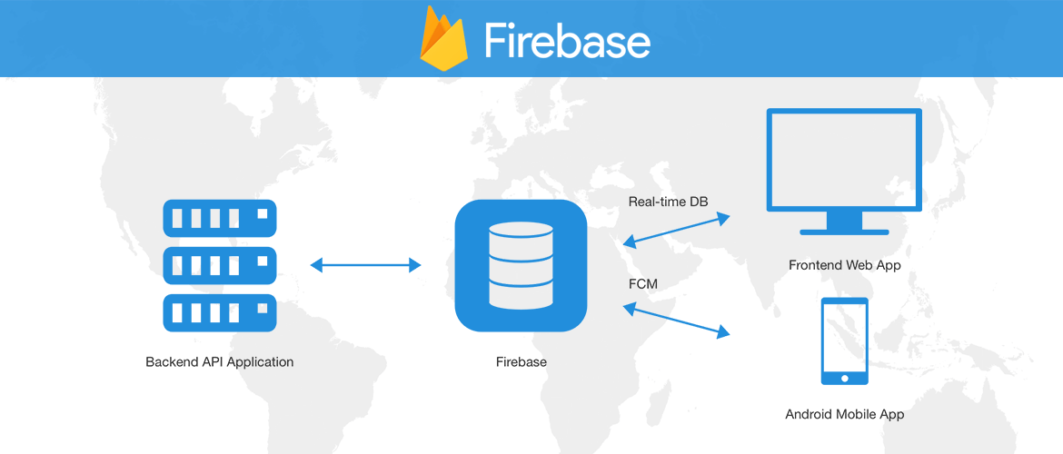

### 

### Algorithm and Process Design:

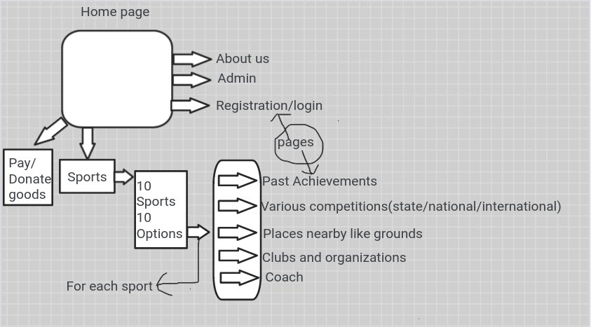

### This is the actual flow of how our project works.

**The above diagram is a pictorial representation of our project.**

### Experiment and Results:

### Home Page:

### a)

### 

### b)

### 

### c)

### 

### User Login

### a)

### 

### b)

### 

### User Registration

### 

### Forget Password

### a)

### b)

### 

### Welcome Page

### a)

### 

### b)

### 

### Donate Page

### 

### Donate Money

### a)

### b)

### 

### c)

### 

### Donate Goods

### a)

### 

### b)

### 

### c)

### 

### Sports Page

### 

### Hockey Page

### 

### Shooting Page

### 

### Achievements Page

### 

### Maps Page

### 

### Clubs & Organizations Page

### 

### Places to Practice Page

### 

### Competitions Page

### 

### Details of Hardware & Software:

#### Hardware Details-

* Processor i5 (8th gen)
* 8gb memory,
* 64 bit Operating system
* Hard disk- 512 gb.

#### Software Details-

#### IDE for Project.

#### Node.js framework. Rather than writing the code using Node.js and creating loads of Node modules, Express makes it simpler and easier to write the back-end code. Express helps in designing great web applications and APIs. Express supports many middlewares which makes the code shorter and easier to write.

* Node.js provides a JavaScript Environment which allows the user to run their code on the server (outside the browser). Node pack manager i.e. npm allows the user to choose from thousands of free packages (node modules) to download.

### Conclusion:

* This web application is an Informatory Sports Website.
* It has great UI and it is User-Freindly.
* It has Login and Register Facilty for Users to avail the functionalities of Website.
* It will be honor to us, if we could help to enhance the performance of Indian at Olympics.

### Future work:

* Currently due to limitations we have added only 10 Olympics sports and will add more sports in Future .
* We have added Olympics games and in future we scope to add Paralympic games too.

**References**

* **Sites**
* <https://kheloindia.gov.in/>
* <http://www.sportsauthorityofindia.nic.in/sai/>
* https://www.nationalsportstalenthunt.com/iFileSAI/
* https://olympic.ind.in/
* <https://olympics.com/ioc/india>
* **Photos**
* https://www.pinterest.com/yobro/sports-photography/
* https://unsplash.com/images/sports
* https://www.freepik.com/photos/sports